**A**

**Minor Project Report**

on

**COVID -19 ANALYSIS AND PREDICTIONS USING DEEP LEARNING**

Submitted for partial fulfillment for the degree of

**Bachelor of Technology**

(Information Technology)

in

Department of Information Technology

by

Vanshika Mediratta

189302025

Mayank Aggarwal

189302045

Under the Guidance of

Dr Nripendra Narayan Das

(July-2021)

**SCHOOL OF COMPUTING AND INFORMATION TECHNOLOGY**

**MANIPAL UNIVERSITY JAIPUR**



**CERTIFICATE**

Date

This is to certify that the project titled **COVID-19 Predictions and Analysis Using Deep Learning** is a record of the bonafide work done by **Vanshika Mediratta** (189302025) and **Mayank Aggarwal** (189302045) submitted in partial fulfilment of the requirements for the award of the Degree of Bachelor of Technology (B.Tech) in **Information Technology** of Manipal University Jaipur, during the academic year 2020-21.

**Dept Guide Name**

*Project Guide, Dept of (Name of the Dept.)*

*Manipal University Jaipur*

**HOD Name**

*HOD, Dept of (Name of the Dept.)*

*Manipal University Jaipur*

**ABSTRACT**

**Purpose:**  Coronavirus disease 2019 (COVID-19) is a contagious disease caused by severe acute respiratory syndrome coronavirus 2 (SARS-CoV-2). The first case was identified in Wuhan, China, in December 2019. After that in 2020, the virus started spreading across the world affecting everybody and resulting in depletion in many other things like the economy, living conditions, obstruction in development, etc. COVID-19 has become the hot topic of the decade and analysis and prediction can benefit in discovering new patterns and trends in reports gathered through various international sources and even enforce precautionary measures for the future. Deep Learning has proved to be very helpful in the healthcare system. Applying those techniques in predicting COVID-19 became one of the most researched topics.

**Keywords:** COVID – 19, Chest X-Ray, Data Visualization, CNN, (model name), (other important things.)

**Approach:** Using EfficientNetB3 and training the algorithm for 20 epochs. Using augmented images to further help in extracting features.

**Results:** The proposed solution was established after training the same set of images. It was also tested on unseen validation data and the best performing model was selected.

**Conclusions:** Current way of testing while very useful is very time taking. While researchers are trying other methods, some found that the chest X-ray of a person with COVID had some distinct features from that of a person infected with Pneumonia and those who had no diseases. It could hence also be able to predict whether a person has COVID or not. As can be seen from the research, evaluation of CT -Scans has proved to be more efficient and accurate.

i

**LIST OF TABLES**

|  |  |  |
| --- | --- | --- |
| **Table No** | **Table Title** | **Page No** |
|  |  |  |
|  | Related Work | 8 |
|  | Model Evaluation and Results | 21 |

**LIST OF FIGURES**

|  |  |  |
| --- | --- | --- |
| **Figure No** | **Figure Title** | **Page No** |
|  |  |  |
|  | Confirmed Cases of COVID - 19 | 11 |
|  | Total Deaths due to COVID - 19 | 11 |
|  | Total Vaccination for COVID - 19 | 12 |
|  | New COVID – 19 Cases | 13 |
|  | Comparison Between New Cases and Deaths | 13 |
|  | Comparison Between New Vaccinations and Vaccinations per Million | 14 |
|  | X-Ray Classes | 15 |
|  | Augmented Images | 16 |
|  | Custom CNN Architecture | 17 |
|  | EfficientNetB3 Architecture | 18 |
|  | VGG16 Architecture | 19 |
|  | ResNet152 Architecture | 19 |
|  | Result Analysis | 20 |

ii

Table of Contents

Abstract…………………………………………………………………………………………….i

List of figures ……………………………………………………………………………………..ii

List of tables...…...………………………………………………………………………………………..ii

1. Introduction 6

2. Literature Review 7

2.1 Summary of related work 8

3. Parent Objective 9

4. Methodology 9

4.1 Data Collection and Preprocessing 10

4.2 Data Visualization 10

4.2.1 Spatial Analysis……………………………………………………………………10

4.2.2 Time Series Analysis………………………………………………………………12

4.3 Predictions…………………………………………………………………………………14

5. Evaluation 19

5.1 Evaluation Metrics…………………………………………………………………...……19

6.Experiment Analysis 20

7. Conclusion 21

8. Future work 21

REFERENCES 22

## 

## **1.** **Introduction**

Acute metabolism syndrome coronavirus two (SARS-CoV-2), an epidemic that causes COVID-19, has become an epidemic since it emerged in the metropolis, China in December 2019. The toll from unwellness is increasing at an associate minacious rate and plenty of health systems worldwide with them. Social isolation is one in all how the planet Health Organization (WHO) has projected to regulate the unfolding of the virus. A vital step during this is to effectively and expeditiously diagnose COVID-19 patients and so positive cases receive timely treatment and live} suitably isolated from society; a measure that's thought-about vital in preventing the unfolding of the unwellness. Reverse-transcription enzyme chain reaction (RT-PCR) testing, which might observe CoV-2 ribonucleic acid from respiratory sorts (such as cavum or cavity swabs), maybe take a look at the methodology for police work COVID-19 cases. The high sensitivity of the RT-PCR taken is obscured by the restricted convenience of taking a look at kits and therefore the time needed for the result to be obtained (a few hours to each day or two).

Therefore, there is a growing need to use fast and reliable testing methods that can also be verified with RT-PCR testing. Some studies have suggested the use of imaging techniques such as X-rays or Computed Tomography (CT) for breast cancer to look at the obvious signs associated with SARS-CoV-2 infection.[1] Chest X-Rays are a very useful tool used to diagnose various ailments. Some of these diseases include fibrosis, pneumonia, edema, pneumothorax, etc. The same method is used for this new disease COVID - 19. This project aims to look at specific methods and patterns with the help of various Deep Learning to come Algorithms that can open the gate for discovery and discovery. The main Deep Learning algorithms used are CNN (Convolutional Neural Networks), EfficientNetB3, VGG16, ResNet50, MobileNetV2. All of these algorithms are used after using various data augmentation techniques.

One of the most commonly used techniques in determining COVID 19 has been RT-PCR (Reverse Transcription Polymerase Chain Reaction) testing. It is one of the most sensitive techniques for mRNA detection currently available. This testing acquires the sample form places which have an amplification of the disease. In this case, the throat and nose. The samples take about 24 – 48 hours to get tested and provide an accurate result. The accuracy of these results range from 78.2% to 97.3 %. Rapid RT PCR testing further has a lower accuracy range. This facilitated the chain of having better model testing methods.[2]

With the wake of Deep Learning in the healthcare industry, the idea came to employ deep learning algorithms to produce better, faster and more accurate results when dealing with this super spreader disease. Several algorithms were deployed each recording varying accuracies until the best model was selected.

This paper deals with the same models being applied on a custom chest x-ray dataset to determine the best model.

1. **Literature Review**

The use of Machine Learning and Deep Learning is making a lot of differences in the medical field with advancements in cancer detection and other prominent diseases. With the recent outbreak of COVID-19, many scholarly researches have put forth their work for the world to view. We used these research papers to get a better understanding to carry out our research wisely.

Prottoy Saha and others[3] made use of four ML classifiers combined to develop an ensemble of classifiers, which ensured better results for the dataset of various sizes and resolutions. The models were trained and tested with a dataset of 1320 images where recent developing systems have conducted their research with comparatively small COVID-19 datasets. The model showed excellent performance with 98.91% accuracy, 100% precision, 97.82% recall, and 98.89% F1-score.

Amit Kumar Das and others[4] used three state-of-the-art deep learning models and ensembled them. The proposed model has achieved a classification accuracy of 95.7%. Even more important fact is it has given a sensitivity of 98%.

Moutaz Alazab and others[5] constructed a diagnosis model using VGG16 to detect COVID-19 using chest X-ray images. The model allows the rapid and reliable detection of COVID-19, enabling it to achieve an F-measure of 99% using an augmented dataset. In a future study, we will consider diagnosing COVID-19 in chest CT scan images using the VGG-XX versions and compare their performances using larger datasets.

Rachana Jain and others[6] used InceptionNetV3, XCeptionNet, ResNeXT models to finally select XceptionNet mode which gave them an accuracy of 97.97%.

Varalakshmi and others[7] used Haralick features which were extracted from the images and constructed VGG16 model to classify 407 COVID-19 chest X-Rays and 5,232 Pneumonia and Normal chest x-ray images. It produced a precision of 91%, recall of 90% and accuracy of 93%.

Worapan Kusakunniran and others[8] focused on heatmap generation to detect COVID-19. They used 325 COVID-19 images, 5218 normal x-ray images, 100 images belonging to elderly patients with minimal fibrosis, 100 images belonging to patients suffering from diseases like tuberculosis, pulmonary edema etc. They developed a ResNet101 model which provided a sensitivity, specificity and accuracy of 97%, 98% and 98% respectively and visualized using U-Net heatmap.

**3.1 Related Work**

|  |  |  |  |
| --- | --- | --- | --- |
| **Paper** | **Author** | **Approach** | **Accuracy** |
| EMCNet: Automated COVID-19 diagnosis from X-ray images using convolutional neural network and ensemble of machine learning classifiers[3] | Prottoy Saha, Muhammad Sheikh Sadi, Md. Milon Islam | The proposed EMCNet has developed a simple CNN network to extract features. In general, CNN has three different layers: convolutional layer, pooling layer | 100% precision, 96.52% recall, 96.52% accuracy, and 98.23% F1-score for COVID-19 classes and 96.64% precision, 100% recall, 100% accuracy, and 98.29% F1-score for normal classes. |
| Automatic COVID-19 Detection from X-Ray images using Ensemble Learning with Convolutional Neural Network[4] | Amit Kumar Das, Sayantani Ghosh, Samiruddin Thunder, Rohit Dutta, Sachin Agarwal and Amlan Chakrabarti | Three pre-trained CNN models were used DenseNet201, Resnet50V2 and Inceptionv3 | Accuracy = 95.7% Sensitivity = 98% F1 Score = 96.2% |
| COVID-19 Prediction and Detection Using Deep Learning[5] | Moutaz Alazab, Albara Awajan, Abdelwadood Mesleh, Ajith Abraham, Vansh Jatana, Salah Alhyari | Developed a simple CNN network to extract features | The CNN-based COVID-19 detector trained on an un-augmented dataset achieved a weighted average F-measure of 95%. The same COVID-19 detector achieved a weighted average F-measure of 99% |
| Deep learning based detection and analysis of COVID-19 on chest X-ray images [6] | Rachna Jain & Meenu Gupta & Soham Taneja & D. Jude Hemanth | Used InceptionNetV3, XCeptionNet, ResNeXT | The Xception model gives  the highest accuracy (i.e., 97.97%) |

1. **Project Objective**

* Objective is to visualize, clean and model the algorithm to give out the best possible and accurate result.
* We could apply this result to further deepen our understanding of the disease by performing deep learning algorithms like CNN for classification of a healthy and infected lung.

## **Methodology**

For optimum and organized results, we have done analysis and prediction on some present times datasets. This methodology is properly documented below majorly in three sections:

* Data Collection & Preprocessing
* Data Visualization
* Prediction

## **4.1.** **Data Collection & Preprocessing**

There are two datasets used in this research work, one for the Data Visualization part with the help of Tableau (by Salesforce)[9] and the other one is for the CNN trained model for which Python is used -

1. Our World in Data[10]

The dataset being used for Data Visualization and Analysis is OWID (Our World In Data) which is a scientific online publication that focuses on large global problems such as poverty, disease, hunger, etc. This dataset contains tuples of about 80,000+ which gets updated on a daily basis, and the set is time-series data for the countries in the world (193), provided with their population and population density as well. The important attributes of this dataset that have come to our use are the daily report on the covid19 cases, deaths, tests done, and vaccinations.

1. Kaggle[11]

The dataset being used for training purposes is the COVID-19 Radiology Dataset from Kaggle. The dataset comprises 3 classes of chest X-rays namely: Normal, Viral Pneumonia and COVID-19. The total number of X-rays available for COVID is: 3616 , Viral Pneumonia : 1346 and 10,192 Normal X-rays. developed the database of COVID-19 x-ray images from the Italian Society of Medical and Interventional Radiology (SIRM) COVID-19 DATABASE , Novel Coronavirus 2019 Dataset developed by Joseph Paul Cohen and Paul Morrison, and Lan Dao in GitHub and images extracted from 43 different publications.

## **4.2.** **Data Visualization**

Data Visualization is a graphical representation of data using charts, graphs, tables, and maps, etc. This technique is imperative as it allows us to see the trends and patterns in the data more clearly and effectively, which results in a better understanding of the data. These data visualization tools and techniques come to use even more when dealing with Big Data to analyze it and make data-driven decisions. In this study of Covid19, the software used for Data Visualization in Tableau. As far as Covid19 is concerned, it is very important to know the status of the spread factor across the world before moving ahead towards getting a conclusion with the help of the CNN Model.

## **4.2.1. Spatial Analysis**

Spatial analysis[12] includes any of the formal techniques which studies entities using their topological, geometric, or geographic properties. Here we have done it on three parameters -

1. Total Confirmed Cases
2. Total Deaths
3. Total Vaccinations

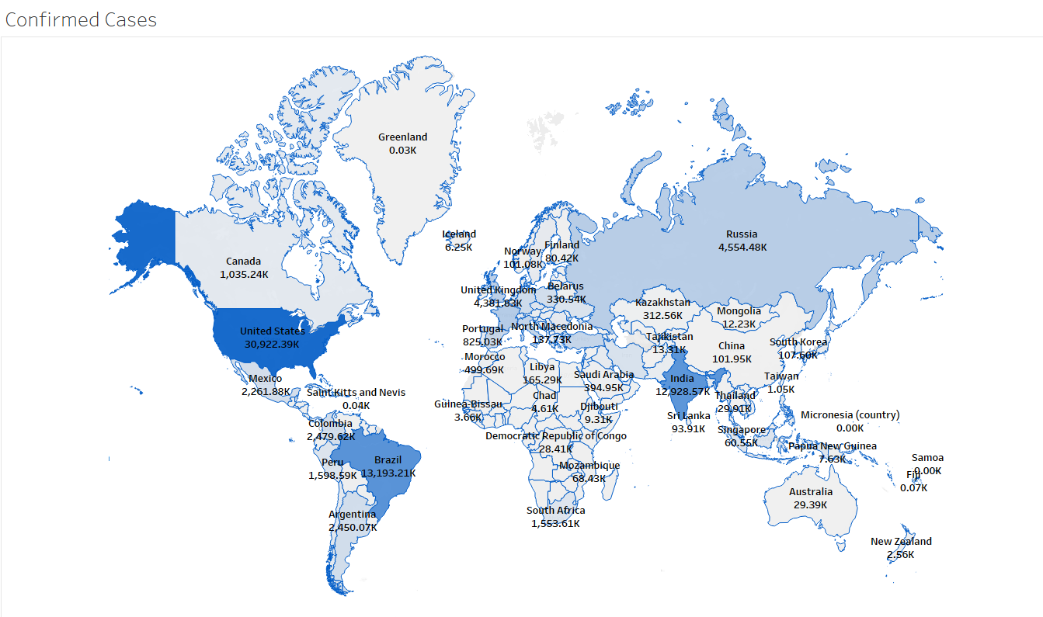

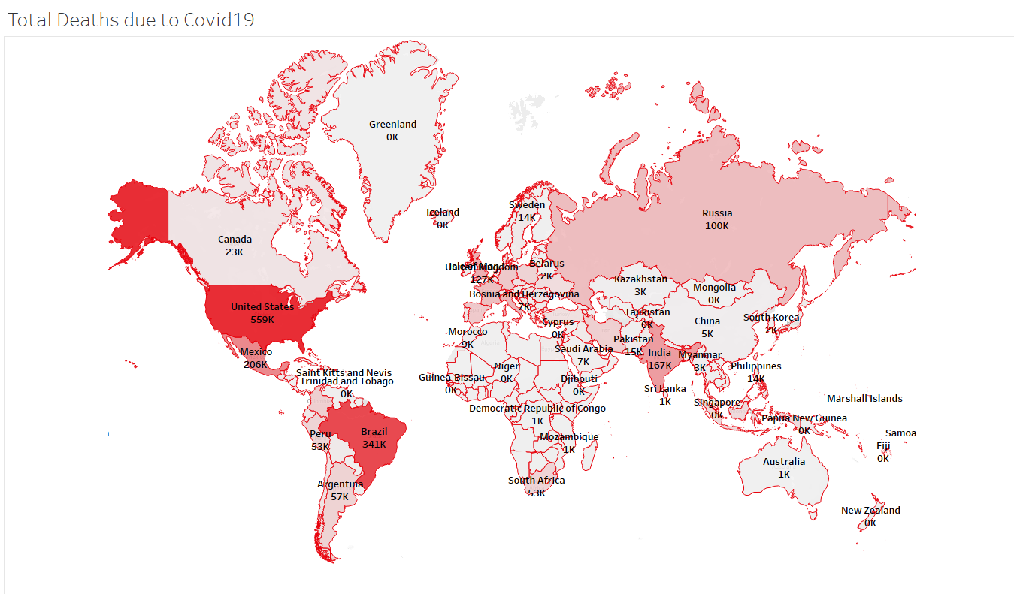

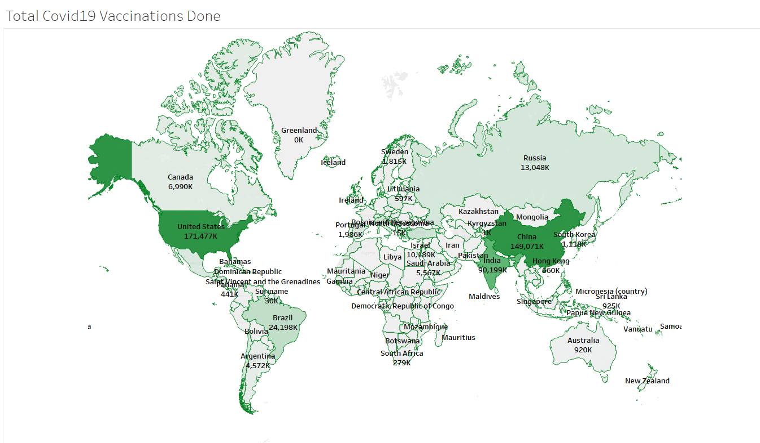

## **4.2.2. Time-Series Analysis**

Time series analysis[13] is a statistical technique that deals with time series data, or trend analysis. Time series data means that data is in a series of particular time periods or intervals. Here we have used this technique for 3 trends we could look for -

1. New Covid-19 Cases
2. Comparison b/w New Cases and Deaths
3. Comparison b/w New Vaccinations and New Vaccinations per million

*(i) New Covid-19 Cases*

The graph shown in the next slide helps us visually analyze the Active Covid19 Cases trends for all the continents. From which we can clearly see that at the end of 2020 the cases were highest in Europe and North America. In Asia, there is a different kind of pattern to be seen in which in January - February 2021 the cases were dropping by a lot, but after March started, the cases in Asia have peaked like never before and it is still increasing as we speak. This increase in Asia currently indicates a second wave of Covid19 for which there could be many reasons like the Mutant State of Covid19 Traces, Lack of precaution, etc.

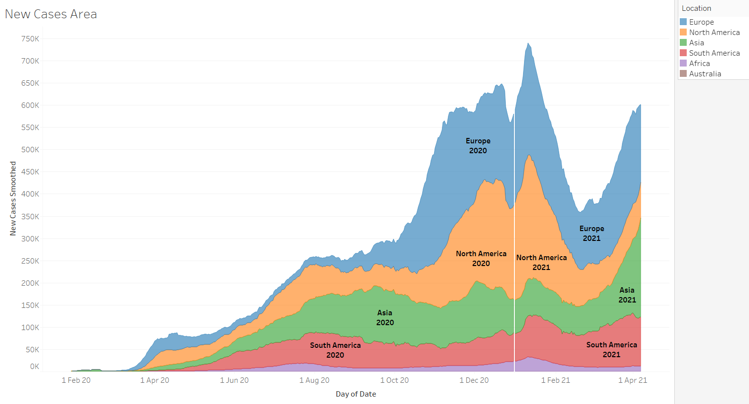

*(ii) Comparison b/w New Cases and Deaths*

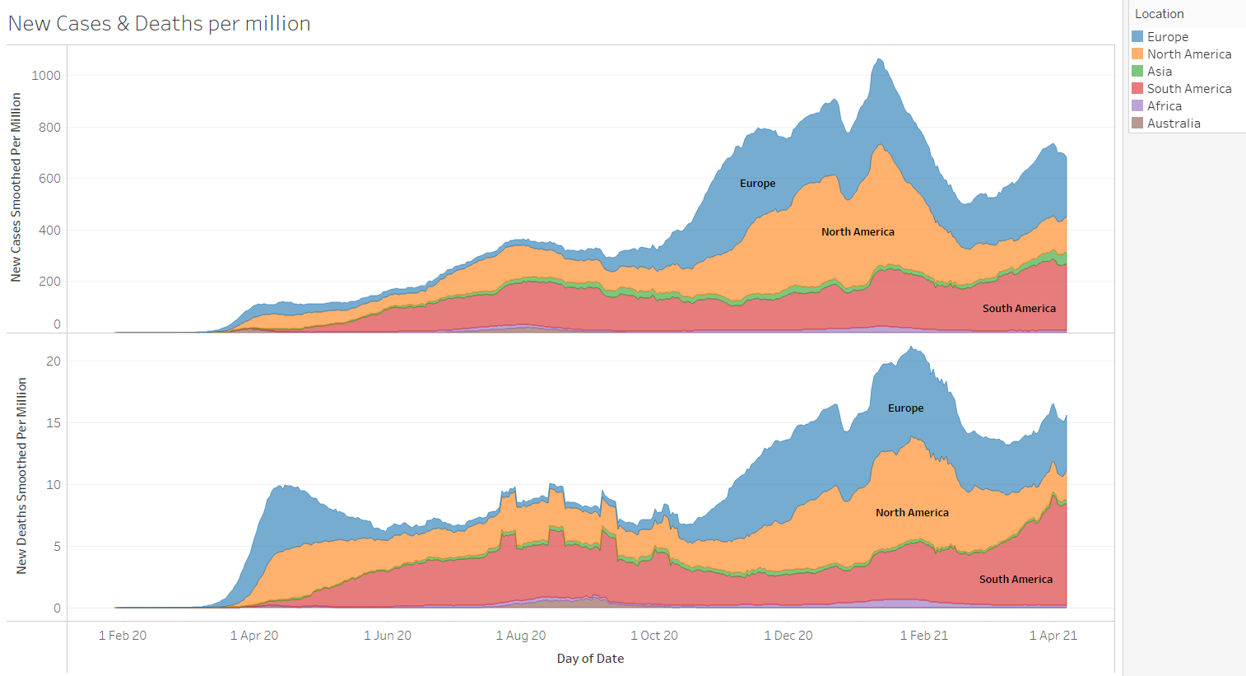

*(iii) Comparison b/w New Vaccinations and New Vaccination per Million*

The graph shown in the next slide helps us visually analyze the difference between New Vaccinations and New Vaccinations per million. From what you can observe like suppose for Asia, the increase in new vaccinations is drastic and has spiked even more since March 2021. But, if we take a look at New Vaccinations per Million then it comes 3rd to 4th among the six continents (Antarctica not included), this is due to the population in Asia is 456 crores, which is more than half of the world population. This means that the increase in vaccinations should increase even more to meet up with the population of the continent.

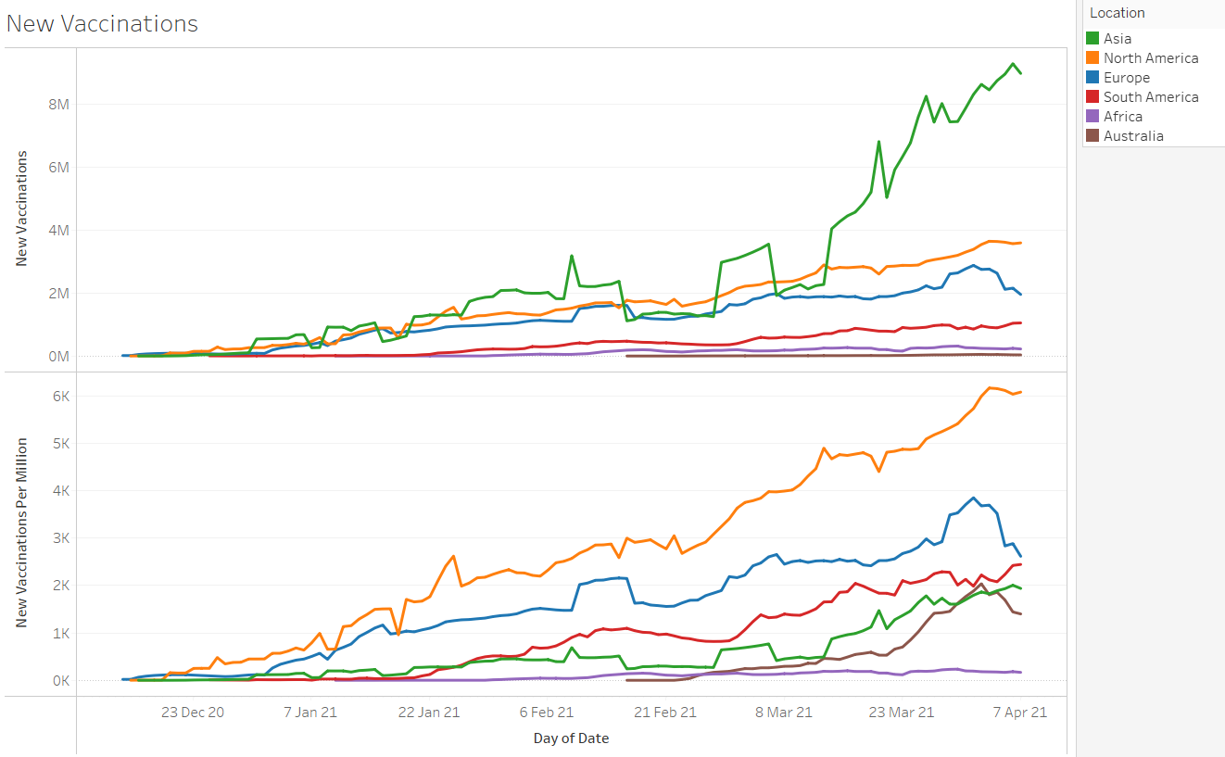

## **4.3.** **Prediction**

To develop the model and make sure it works correctly, we use x-ray images from COVID-19 Radiology Dataset from Kaggle and Chest X-Ray Images (Pneumonia) also from Kaggle. Total number of images used was 10,484. The three classes were equally balanced with Normal, COVID-19 and Viral Pneumonia each having 3616 images.

Given below are the images for each of these classes respectively:

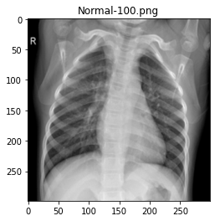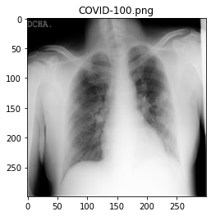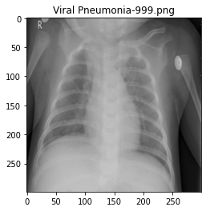

X-RAY CLASSES

As can be seen from the three images, we cannot classify the images with our naked eyes. This is where Deep Learning is useful.

All these images were resized to 224x224 pixels. We used data augmentation parameters[14] like zoom range, shear range and rotation to create more diverse images. The image below portrays the difference between the original image and augmented image.

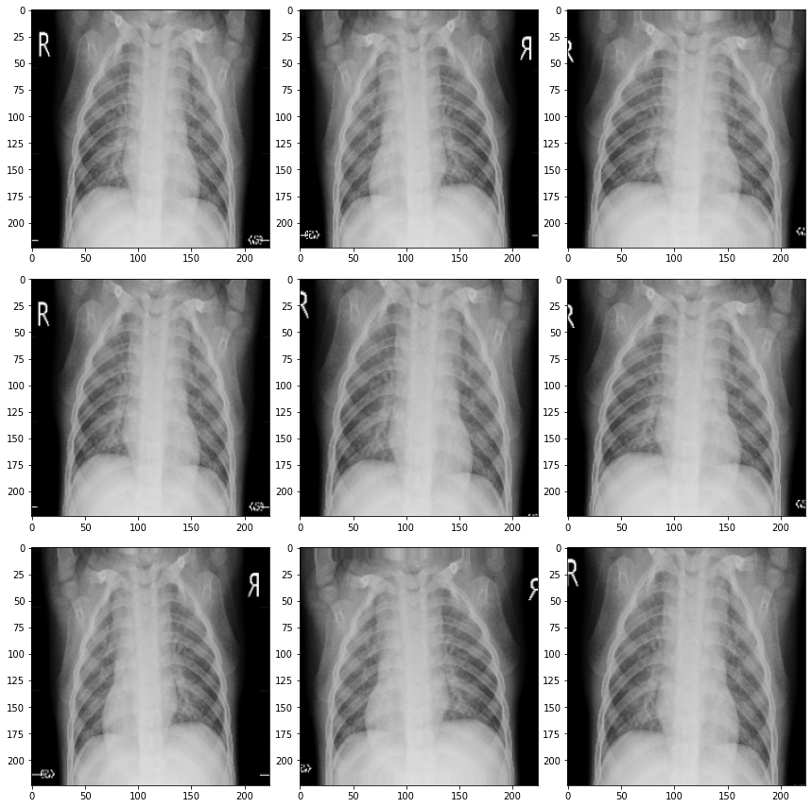

Augmented Images

This dataset was split into train and test data with a test size of 0.2 meaning training data had 8387 images and validating/testing data having 2097 images.

The training pipeline was then constructed using a custom CNN model[15], EfficientNetB3[16], ResNet152[17], VGG16[18] and MobileNetV2[19] algorithms. Each had a learning rate of 1e-4, and ran for 10-15 epochs.

### *(i) Custom CNN Model*

The CNN model[20] used by us has a total of 21 layers using Conv2D, MaxPool2D, BatchNormalization, Dropout, Dense and Flatten. The layers are attached below: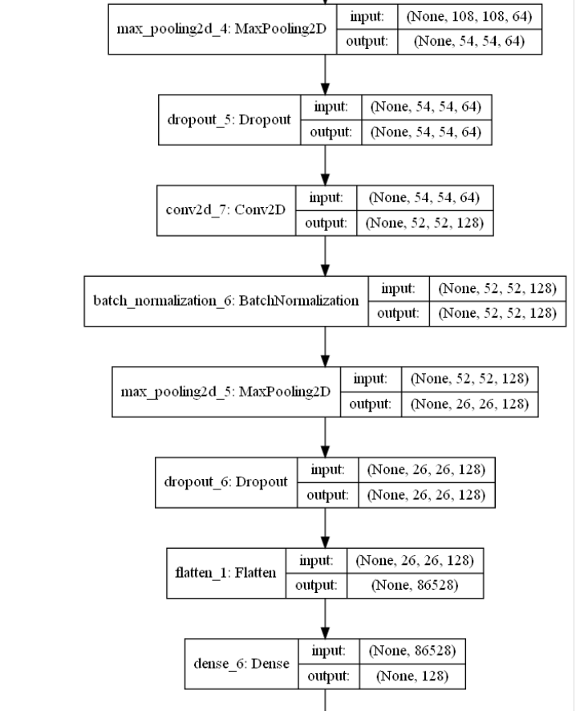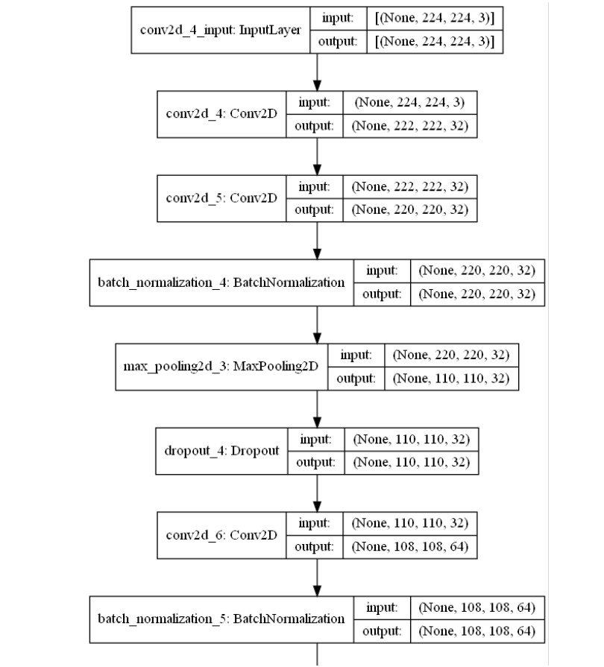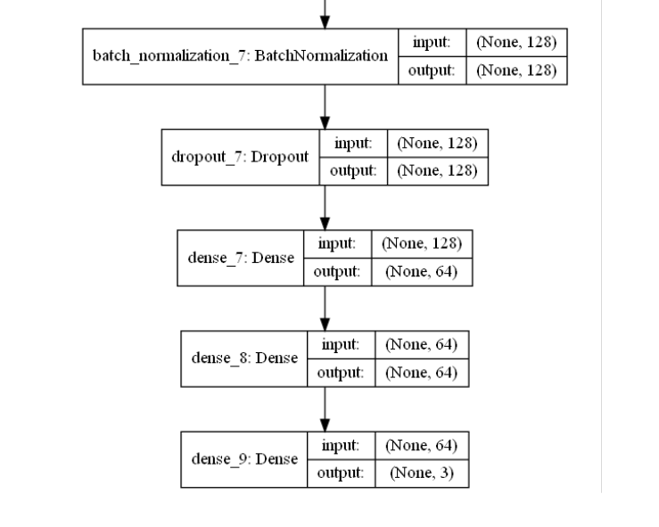

Custom CNN Architecture

The validation accuracy achieved here reached a maximum of 83.51% . However there were a lot of discrepancies in the running epochs hence this was not considered for the final model.

### *(ii) EfficientNetB3*

**EfficientNet** is a convolutional neural network architecture and scaling method that uniformly scales all dimensions of depth/width/resolution using a *compound coefficient*. Unlike conventional practice that arbitrarily scales these factors, the EfficientNet scaling method uniformly scales network width, depth, and resolution with a set of fixed scaling coefficients. Given below are the layers in EfficientNet.

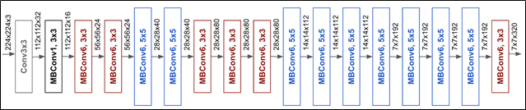

EfficientNetB3 Architecture

With our pipeline, we use a batch size of 32, learning rate of 1e-4 and 10 epochs. The highest validation accuracy attained is 98.6%

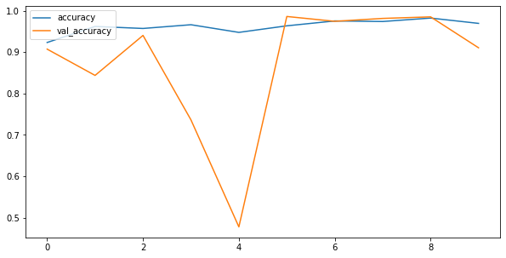

Accuracy Graph

### 

### *(iii) VGG16*

**VGG16** is a convolutional neural network model proposed by K. Simonyan and A. Zisserman from the University of Oxford in the paper “Very Deep Convolutional Networks for Large-Scale Image Recognition”[21]. The model achieves 92.7% top-5 test accuracy in ImageNet, which is a dataset of over 14 million images belonging to 1000 classes. While working very well with some other datasets, the model didn’t perform very well with signs of overfitting. Hence this model too was not selected as the final model.

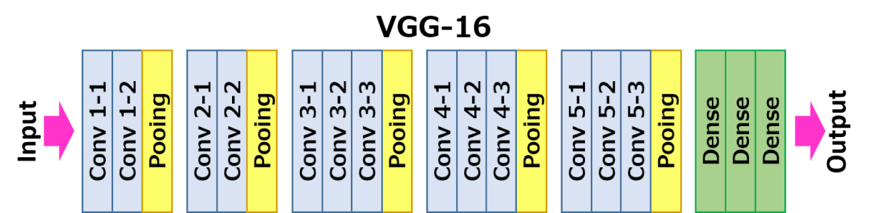

VGG-16 Architecture

### 

### *(iv) ResNet152*

**ResNet** can have a very deep network of up to **152** layers by learning the residual representation functions instead of learning the signal representation directly. Given below is the architecture for ResNet152.

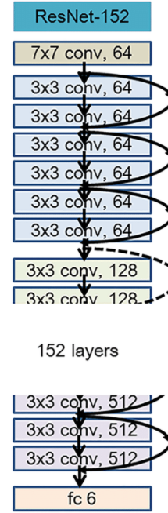

ResNet152 Architecture

Validation accuracy achieved with this was 93.14%.

## **Evaluation**

**6.1 Evaluation Metrics**

The training process is carried out using train_test_split[22] which splits the data into two sub datasets in the ratio 8:2. First set is the training set and the second set is the validation set. The metrics involved in this accuracy[23]. The formula for which is given below:

In the above equation, TP is True Positive, TN is True Negative, FP is False Positive, FN is False Negative. True Positive means that the model correctly identified all the images which belonged to their original class. True Negative means that the model correctly identified which image did not belong to a particular class. False Positive means the model wrongfully classified the image to be COVID-19 when it was not. False Negative means the model wrongfully classified an image to a different class meaning the image belonged to COVID-19 but was classified as Normal.

1. **Experiment Analysis:**

In this section we see how our model performed with respect to the validation set and which model was finally selected.

### *(i) Experiment Setup*

The experiment was run on Google Collaboratory. It is a Jupyter notebook based cloud service for working on Machine Learning and a free of charge access to a stable GPU with certain limitations.

### *(ii) Result Analysis*

The figure shows the epochs that the model ran. There were a total of 10 epochs that were run on the EfficientNetB3 model and provided an accuracy of 98.6%.



The results from all the models are summarized below:

|  |  |
| --- | --- |
| MODEL | VALIDATION ACCURACY |
| EfficientNetB3 | 98.6% |
| ResNet152 | 93.18% |
| VGG16 | 91.13% |
| MobileNetV2 | 88.56% |
| Custom CNN | 83.51% |

## **7. Conclusion:**

COVID-19 pandemic has posed a lot of challenges for people all over the world. With not much information available, it gets increasingly difficult to deal with the disease. However with such technological advances, we are able to correctly extract the features of this disease. Using X-Rays is one efficient way to understand more about the disease. Deep Learning has already made tremendous success in this field and has efficient use with this dataset. EfficientNetB3 algorithm proved to be the most helpful in identifying the minute differences between the three classes.

1. **Future Work**

The focus of this research was to get a better understanding of COVID-19 and use appropriate technology to classify the diseases. With this we also were interested to know if a better and more accurate diagnosis of COVID-19 could be made and used instead of the tradition RT-PCR testing. Our ideas to further enhance the understanding of COVID-19 would keep on increasing. While we are fairly satisfied with how the model has turned out, it would be interesting to carry out more research using Image Segmentation with UNet[24] to further pinpoint where exactly the model predicts the presence of COVID-19. This could increase the visualization of the disease and help with the prognosis making this research better. In conclusion, there are better methods that could be employed to study COVID-19 and with more research on this subject and application of advanced technology, it could create many advancements in the field of Science and Medicine.

# **REFERENCES:**

1. Afshar-Oromieh, A., Prosch, H., Schaefer-Prokop, C. *et al.* A comprehensive review of imaging findings in COVID-19 - status in early 2021. *Eur J Nucl Med Mol Imaging* (2021). <https://doi.org/10.1007/s00259-021-05375-3>
2. Reverse transcription polymerase chain reaction (RT-PCR), Wikipedia
3. Prottoy Saha, Muhammad Sheikh Sadi, Md. Milon Islam, “EMCNet: Automated COVID-19 diagnosis from X-ray images using convolutional neural network and ensemble of machine learning classifiers”.
4. Amit Kumar Das, Sayantani Ghosh, Samiruddin Thunder, Rohit Dutta, Sachin Agarwal and Amlan Chakrabarti, “Automatic COVID-19 Detection from X-Ray images using Ensemble Learning with Convolutional Neural Network”.
5. Moutaz Alazab, Albara Awajan, Abdelwadood Mesleh, Ajith Abraham, Vansh Jatana, Salah Alhyari, “COVID-19 Prediction and Detection Using Deep Learning”.
6. Rachna Jain & Meenu Gupta & Soham Taneja & D. Jude Hemanth, “Deep learning based detection and analysis of COVID-19 on chest X-ray images”.
7. Perumal, V., Narayanan, V. & Rajasekar, S.J.S. Detection of COVID-19 using CXR and CT images using Transfer Learning and Haralick features. *Appl Intell* **51,**341–358 (2021). https://doi.org/10.1007/s10489-020-01831-z
8. Kusakunniran W, Karnjanapreechakorn S, Siriapisith T, et al. COVID-19 detection and heatmap generation in chest x-ray images. *J Med Imaging (Bellingham)*. 2021;8(Suppl 1):014001. doi:10.1117/1.JMI.8.S1.014001
9. Tableau, Tableau.com
10. Our World in Data, [*https://ourworldindata.org/coronavirus-source-data*](https://ourworldindata.org/coronavirus-source-data)
11. COVID-19 Radiology Dataset, Pneumonia Detection, Kaggle
12. Spatial analysis & modelling, Dartmouth.edu
13. The Complete Guide to Time Series Analysis and Forecasting , towards data science
14. Data Augmentation, tensorflow
15. Majeed, T., Rashid, R., Ali, D., & Asaad, A. (2020). Covid-19 detection using cnn transfer learning from x-ray images. *medRxiv*.
16. EfficientNetB3, Tensorflow.org
17. Review Resnet Winner of ILSVRC 2015 Image Classification Localization, Detection, Towards Data Science
18. VGG16, Neurohive.io
19. MobileNetV2, Google AI Blog
20. Islam, M. Z., Islam, M. M., & Asraf, A. (2020). A combined deep CNN-LSTM network for the detection of novel coronavirus (COVID-19) using X-ray images. *Informatics in medicine unlocked*, *20*, 100412.
21. K. Simonyan, Andrew Zisserman, “Very Deep Convolutional Networks for Large-Scale Image Recognition”, 2015
22. Sklearn.model_selection.train_test_split, scikit-learn.org
23. Machine Learning Model Accuracy, datarobot.com
24. U-Net: Convolutional Networks for Biomedical Image Segmentation